|  |
| --- |
| TL Version: How to Edit Sessions in CYSH |

1. Go to CYSH via your [Okta Homepage](https://cityyear.okta.com/app/UserHome) (cityyear.okta.com)

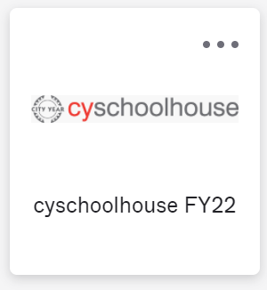

1. Select the section you want to edit time for

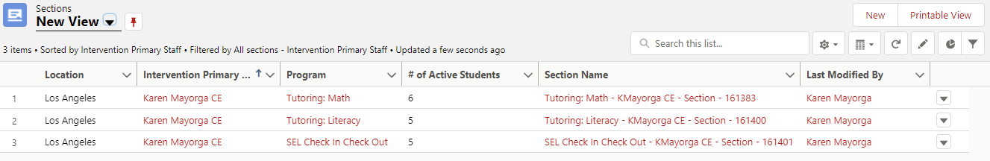

1. Click on Session History

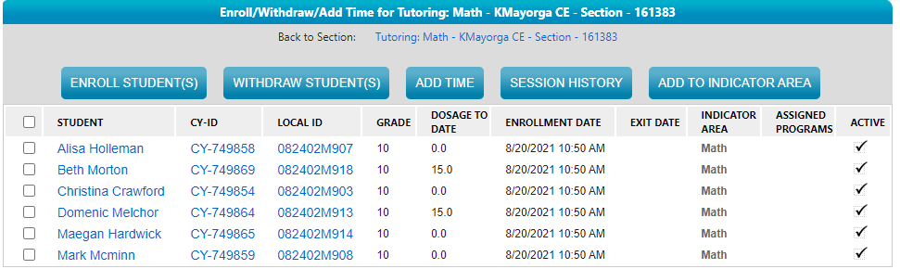

1. Find the section you want to edit using the date filter and click on the session ID

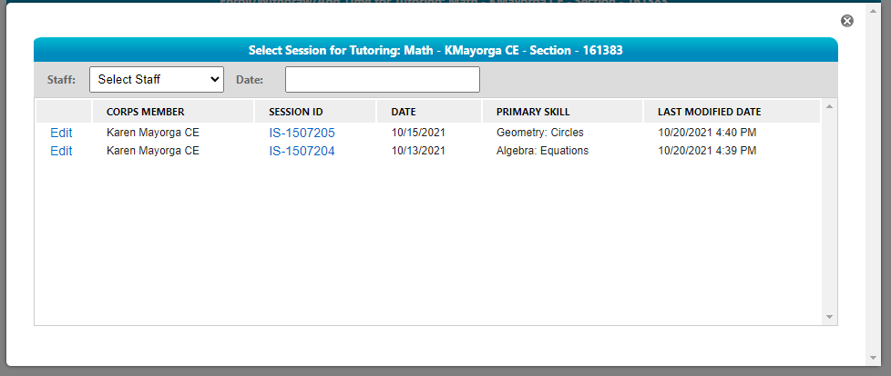

1. Click on the Edit button and make changes to the session as needed, then click Save.

